How to create a web service project using Visual Studio 2013

Since we are using Visual Studio 2013 and the video clip shows Visual Studio 2005, there are some differences that you need to adjust as below:

1. File -> New -> Project

2. Temporarily Select .NET Framework 3.5 from the dropdown list at the top center of the New Project Dialog Box.

3. Select Template "ASP.NET Web Service Application - OK

4. In the Solution Explorer right click on the WebService1 project within the Solution WebService1 - select Properties on the bottom

5. On the Application Tab change the Target framework back to .NET Framework 4.0

6. Confirm all the warning that you'll have to manuall change things, etc.

7. press F5 to start the Hello World App

What should you see:

8: A browser launches with http://localhost:4001/Service1.asmx as the URL with a link named HelloWorld which is the WebMethod

9: Click the HelloWorld Link and click Invoke

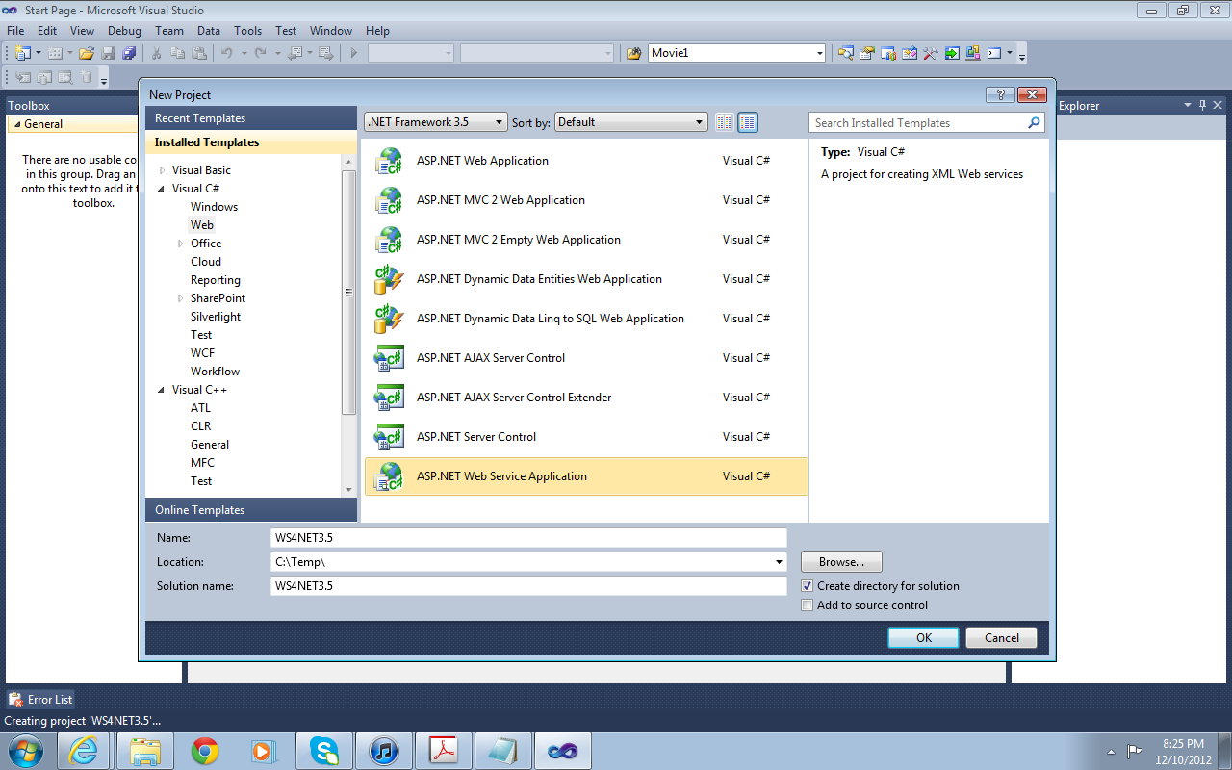

Reset project to .Net 4.0
